### 

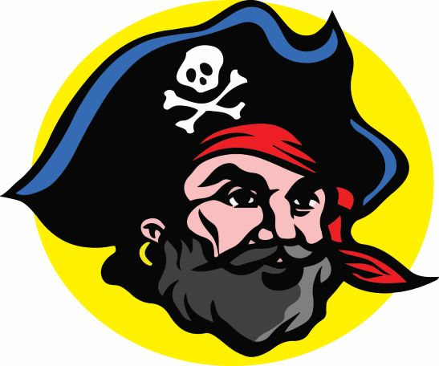

**Pirate Athletic Hall of Fame, Inc.**

**Golf Tournament Winning Teams**

**1995 - 2021**

### 1995 Golf Tournament 1st place winners - 2 teams tied

### Richard Maestrelli Larry Mose Michael Maestrelli Jim Macon

Steve Harper Bruce Hess

Dave Volpi Fred Pratt

### 1996 Golf Tournament 1st place winners

### Larry Moser ‘59

Jim Macon

Charlie Goldson

Mike Slomka

### 1997 Golf Tournament 1st place winners

### Larry Moser ‘59

Doc Riddle

Jim Macon

Jeff Pratt

### 1998 Golf Tournament 1st place winners

### Paul Battle ‘81

Lou Masi

Pat Sokalowski ‘84

Doug Bartell

### 1999 Golf Tournament 1st place winners

### Marvin Ellis

Rick Jerger ‘63

Paul Resop

Paul Wallace

### 2000 Golf Tournament 1st place winners

### Larry Moser ‘59

Jim Macon

John Greene ‘60

Mike Carter

### 2001 Golf Tournament 1st place winners

# Larry Mosier ‘59

Ed Hall

Wayne Stebbins

Jerry Steinmetz

**2002 Golf Tournament 1st place winners**

Larry Moser ‘59

Tom Totten

Gary Moser

Wayne Stebbins

**2003 Golf Tournament 1st place winners**

Karl Meter ‘76

Pat Wiseman ‘76

Doug Jones ‘77

Scott Cook ‘77

**2004 Golf Tournament 1st place winners**

Rex Gaugh ‘78

Kevin Chadwick ‘78

Tomas R. May

**2005 Golf Tournament 1st place winners**

Rex Gaugh ‘78

Kevin Chadwick ‘78

Randy Mosely

Thomas May

**2006 Golf Tournament 1st place winners**

Beth Daniels ‘71

Connie McMullen

Fred Metzger ‘71

Dennis Fieber ‘71

**2007 Golf Tournament 1st place winners**

Rex Gaugh ‘78

Shawn Powers

Dave Pilkington ‘78

**2008 Golf Tournament 1st place winners**

Beth Daniels ‘71

Fred Metzger ‘71

Dennis Fieber ‘71

**2009 – 2013 NO tournaments were held**

**2014 Golf Tournament 1st place winners**

Rex Gaugh ‘78

Joseph Chike

David McCullum

**2015 Golf Tournament 1st place winners**

Mike Castleman ’79

Sadie Chlapowski 2017

Van Chlapowski ‘78

Andy Sonnanstine

**2016 Golf Tournament 1st place winners**

Steve Stewart ‘78

John Phillips

Cam McCreary

Dave Rowe ‘87

**2017 Golf Tournament 1st place winners**

Steve Hodges ‘59

Dick Roberts ‘59

Sam Evans ‘57

**2018 Golf Tournament 1st place winners**

Rex Gaugh ‘78

Mike Bonner

Jay Degeare

Dusty Rose

**2019 Golf Tournament 1st place winners**

Karl Meter ’76

Scott Cook ‘77

Doug Jones

Bill Reischmann ‘76

**2020 NO Golf Tournament DUE TO COVID VIRUS**

**2021 Golf Tournament 1st place winners**

John C. “Wink” Amerman ‘95

Paul Battle ‘81

Zach Taylor

Jeff Taylor